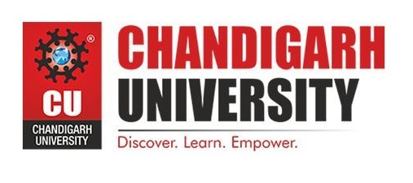

**Reflection Report: Impact of Pradhan Mantri Ujjawala Yojana**

Submitted by : Aryan Dhasmana

23BCB10081 (BE CSE CSBS)

CBS121 - B

Email : 23bcb10081@cuchd.in

**Table of Contents**

**Introduction ………………………………………………………… 3**

**Objective ……………………………………………………………. 3**

**Achievements and Impacts…………………………………………. 9**

* Total LPG Connections Released
* Ujjwala 2.0 Expansion
* Reduction in Health Hazards
* Women's Empowerment
* Environmental Benefits
* Economic Impact

**Eligibility and Statistics ……………………………………………. 6**

**Daily** **Observations ………………………………………………….. 4**

* Day 1: Digging into PMUY – Initial Insights
* Day 2: Challenges – Logistics and Reliability
* Day 3: The Full Picture – Fuel Stacking and household dynamics
* Day 4: The Hilly Hurdle - Accessibility
* Day 5: Success and the road ahead

**Challenges Faced ……………………………………………………. 9**

**Recommendations ………………………………………………….. 10**

**Conclusion ………….………………………………………………. 11**

**Appendices …………………………………………………………. 12**

**Introduction**

Pradhan Mantri Ujjwala Yojana (PMUY), launched on May 1, 2016, is a flagship initiative by the Government of India aimed at providing clean cooking fuel to households living below the poverty line. The scheme primarily focuses on distributing free LPG (Liquefied Petroleum Gas) connections to women from BPL (Below Poverty Line) families, addressing both health hazards from traditional cooking methods and promoting environmental sustainability.

### Objective of the Report

The objective of this reflection report on the Pradhan Mantri Ujjwala Yojana (PMUY) implementation in [Name of Village] is to:

1. **Evaluate Implementation Effectiveness**: Assess how PMUY has been implemented in the village and its impact on beneficiaries, particularly focusing on health outcomes, productivity, and socio-economic factors.
2. **Identify Challenges**: Identify and analyze the challenges faced during the implementation of PMUY, including logistical, infrastructural, and cultural barriers that affect the program's success.
3. **Provide Recommendations**: Offer actionable recommendations based on observed challenges and stakeholder feedback to improve the effectiveness and sustainability of PMUY in Jaiheri.
4. **Document Insights**: Document key insights from interactions with beneficiaries, village leaders, and personal observations to provide a comprehensive understanding of the program's impact and potential areas for enhancement.
5. **Support Decision-Making**: Equip stakeholders, including government officials, policymakers, and community leaders, with data-driven insights and recommendations to support informed decision-making for future program implementation and enhancement efforts.

By fulfilling these objectives, the report aims to contribute to the ongoing efforts to optimize PMUY implementation, ensuring it continues to positively impact the lives of rural residents in [Name of Village] and beyond.

**Achievements and Impacts**

Since its inception, PMUY has achieved remarkable milestones and significantly impacted millions of households across India. Here are some key achievements and impacts of the scheme:

1. **Total LPG Connections Released**:
   * As of June 11, 2024, PMUY has successfully released a total of 103,257,169 LPG connections. This extensive distribution network has played a crucial role in ensuring widespread access to clean cooking fuel across rural and urban areas.
2. **Ujjwala 2.0**:
   * Under Ujjwala 2.0, an extension of the original scheme, an additional 23,400,540 LPG connections have been provided as of June 11, 2024. This phase targets the remaining households and aims to sustain the momentum of clean energy adoption.
3. **Reduction in Health Hazards**:
   * Traditional cooking methods using biomass, coal, or wood are associated with severe health risks, including respiratory diseases and chronic obstructive pulmonary disease (COPD). According to the World Health Organization (WHO), household air pollution from cooking with solid fuels is responsible for over 4 million deaths annually. The adoption of LPG through PMUY has significantly reduced exposure to these harmful pollutants.
4. **Women's Empowerment**:
   * The scheme has empowered women by reducing their time and effort spent on collecting firewood and other traditional fuels. With more time available for education and income-generating activities, women's participation in economic and social spheres has improved. A study by the International Labour Organization (ILO) highlighted the positive impact on women's productivity and well-being due to access to clean cooking fuel.
5. **Environmental Benefits**:
   * By promoting the use of LPG, PMUY has contributed to a reduction in deforestation and carbon emissions. LPG is a cleaner fuel compared to traditional biomass, reducing indoor air pollution and contributing to better environmental health. The switch to LPG aligns with India's commitment to combating climate change.
6. **Economic Impact**:
   * The increased demand for LPG has stimulated the domestic LPG market, leading to job creation in manufacturing, distribution, and maintenance of LPG cylinders and stoves. This has had a positive ripple effect on the economy, particularly in rural areas.

**Eligibility Criteria**

To avail of the benefits under PMUY, the applicant must meet the following eligibility criteria:

* **Adult woman belonging to any of the following categories**:
  + SC Households
  + ST Households
  + Pradhan Mantri Awas Yojana (Gramin)
  + Most Backward Classes
  + Antyodaya Anna Yojana (AAY)
  + Tea and Ex-Tea Garden tribes
  + Forest Dwellers
  + People residing in Islands and River Islands
  + SECC Households (AHL TIN)
  + Poor Household as per 14-point declaration
* **Additional Criteria**:
  + The applicant must have attained 18 years of age.
  + There should not be any other LPG connections in the same household.

**Relevant Statistics**

* **LPG Penetration**: The overall LPG penetration in India increased from 56.2% in 2016 to over 97% in 2021, largely due to the efforts under PMUY.
* **Health Benefits**: A study by the Indian Council of Medical Research (ICMR) found that households using LPG as a primary cooking fuel had a 21% lower incidence of respiratory diseases compared to those using traditional fuels.
* **Economic Savings**: Women in households with LPG connections saved an average of 1.5 hours per day, which they could redirect towards productive activities, thereby contributing to family income and economic stability.

**Daily Observations**

### Day 1: Digging into PMUY

**Activity**: Met with the village head, to discuss the implementation and impact of PMUY in the village. Had conversations with beneficiaries, such as, to understand their experiences firsthand.

**Key Observation**: Many beneficiaries expressed gratitude for the cleaner cooking fuel provided by PMUY, highlighting improvements in health and increased daily productivity.

**Impact**: Improved health outcomes due to reduced exposure to indoor air pollution from traditional cooking methods.

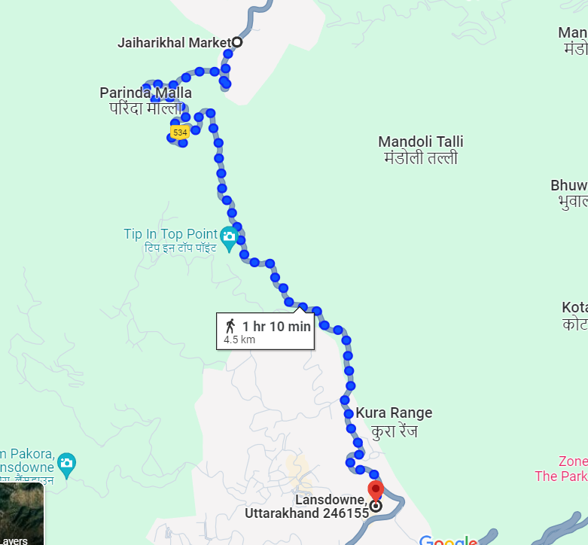

*Fig : Nearest Gas Station around 5 km*

### Day 2: Challenges

**Activity**: Continued conversations with beneficiaries, focusing on challenges faced in accessing and utilizing LPG under PMUY. Visited the local gas station to observe firsthand the logistical challenges in gas cylinder delivery.

**Key Observation**: Irregular service and unreliable delivery systems due to poor infrastructure significantly affect the effectiveness of PMUY in the village.

**Impact**: Inconsistent access to clean cooking fuel undermines health benefits and sustainability of LPG usage.

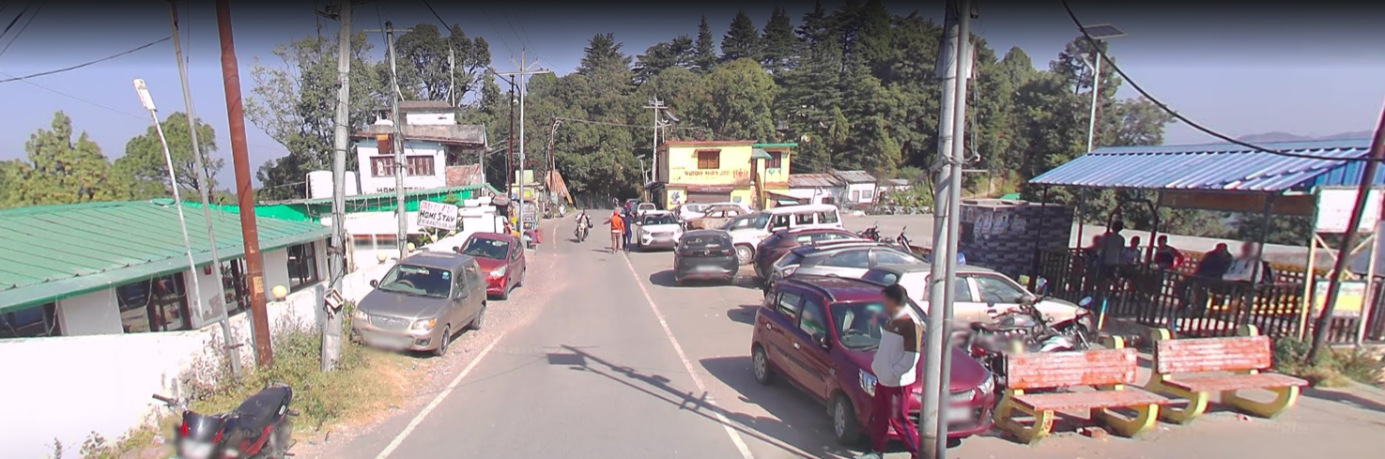

Fig : Village square on the top of the mountain where usually the cylinders are delivered

### Day 3: The Full Picture

**Activity**: Explored the dual use of LPG and firewood in households through discussions with residents like, who highlighted the limitations of LPG for tasks beyond cooking.

**Key Observation**: Despite the adoption of LPG for cooking, households continue to rely on firewood for supplementary tasks, indicating the need for a more comprehensive energy solution.

**Impact**: "Fuel stacking" compromises efforts to fully transition away from traditional fuels, impacting indoor air quality and health outcomes.

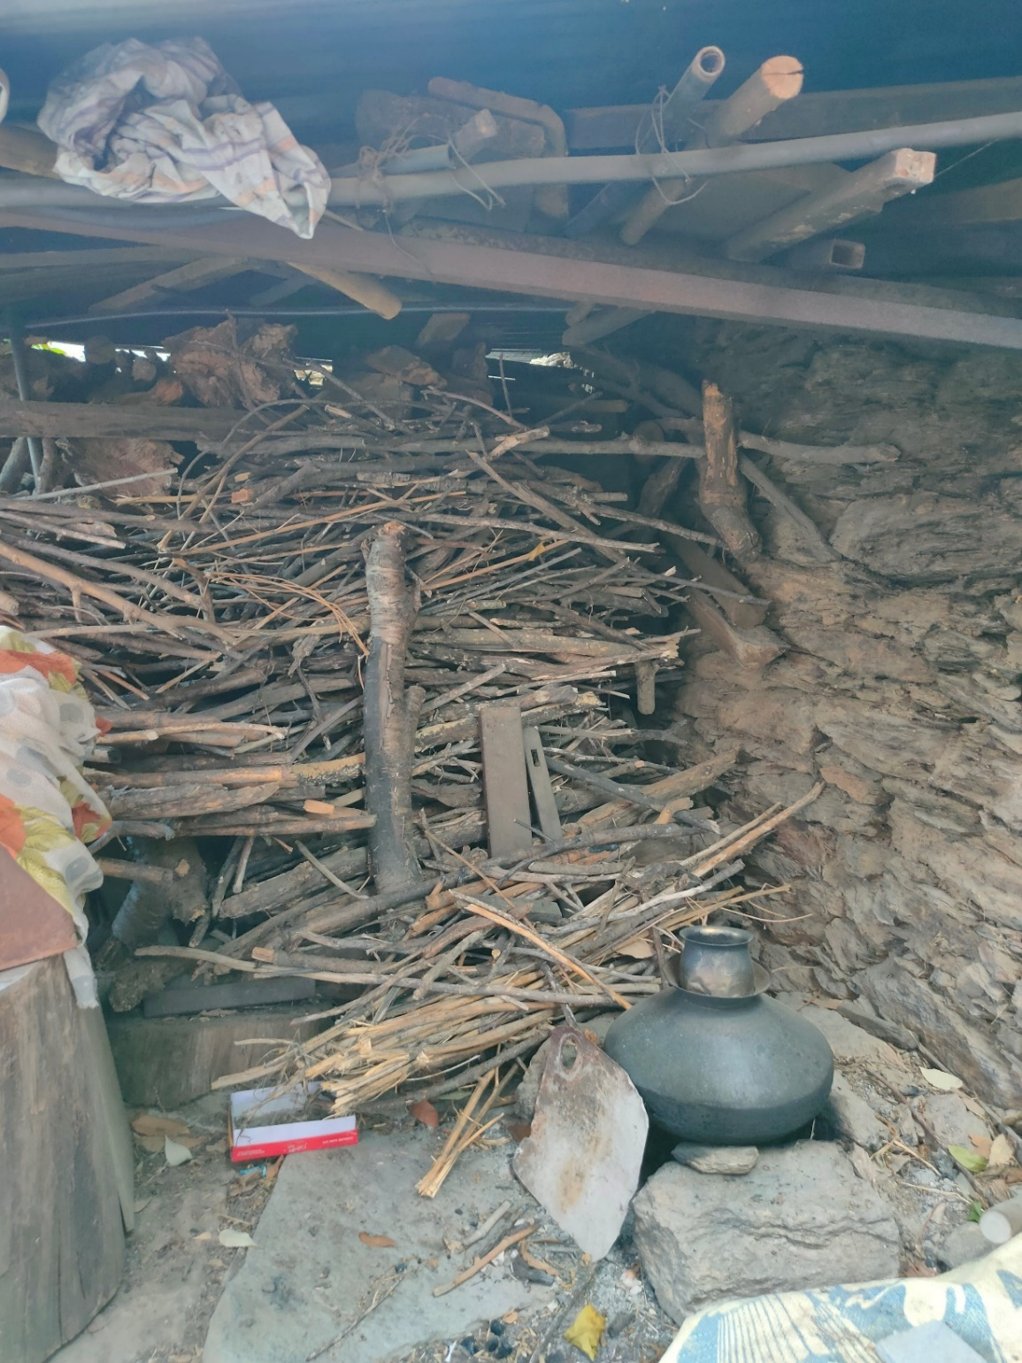

*Fig : Woodstock stored to be used during upcoming winter*

### Day 4: The Hilly Hurdle

**Activity**: Engaged with elderly residents like to understand the specific challenges they face in transporting heavy gas cylinders through the village's hilly terrain.

**Key Observation**: The physical demands of transporting LPG cylinders uphill pose a significant barrier for elderly residents, highlighting accessibility issues in rugged landscapes.

**Impact**: Elderly residents experience heightened physical strain and reduced accessibility to clean cooking fuel, impacting their quality of life.

**Note : *The Village pathways have hardly any space . Demonstrated by the images below .***

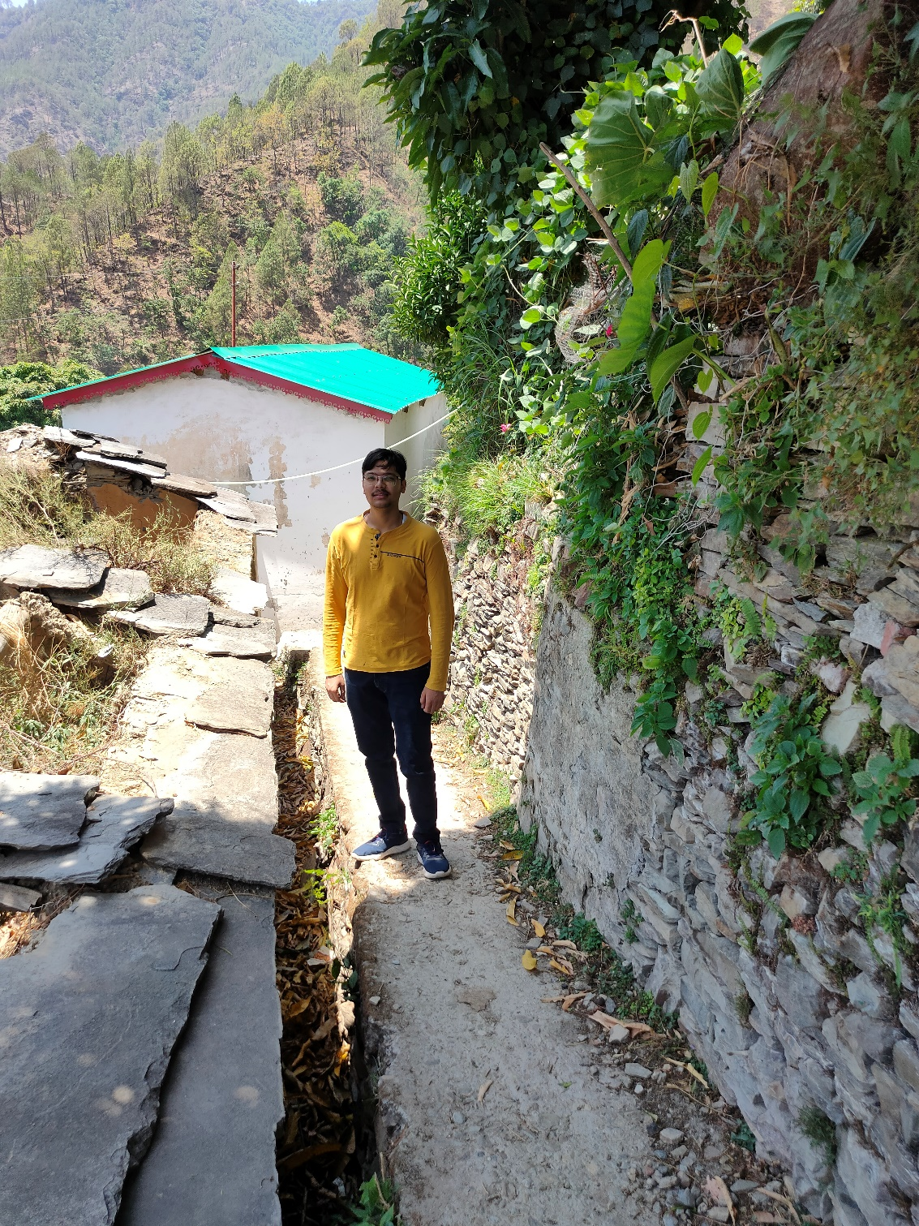

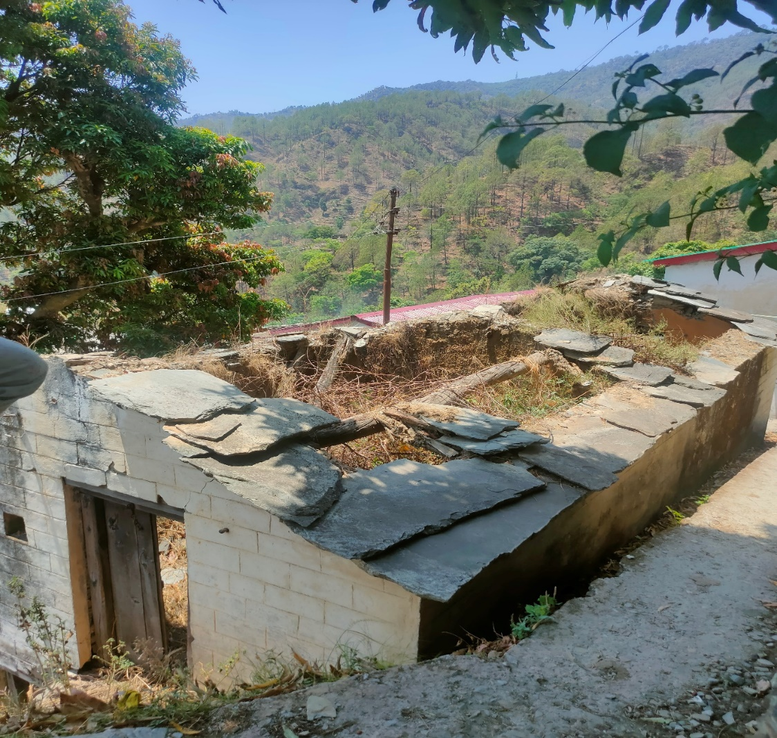

### Day 5: Success and the Road Ahead

**Activity**: Summarized the week's findings and reflected on successes and areas for improvement in PMUY implementation. Formulated recommendations based on observed challenges and community feedback.

**Key Observation**: While PMUY has achieved notable success in improving health and time savings for villagers, infrastructure deficits and cultural practices present ongoing challenges.

**Impact**: Successes in health improvement and time savings underscore the transformative potential of PMUY, while infrastructure deficits and cultural practices necessitate tailored interventions for sustained impact.

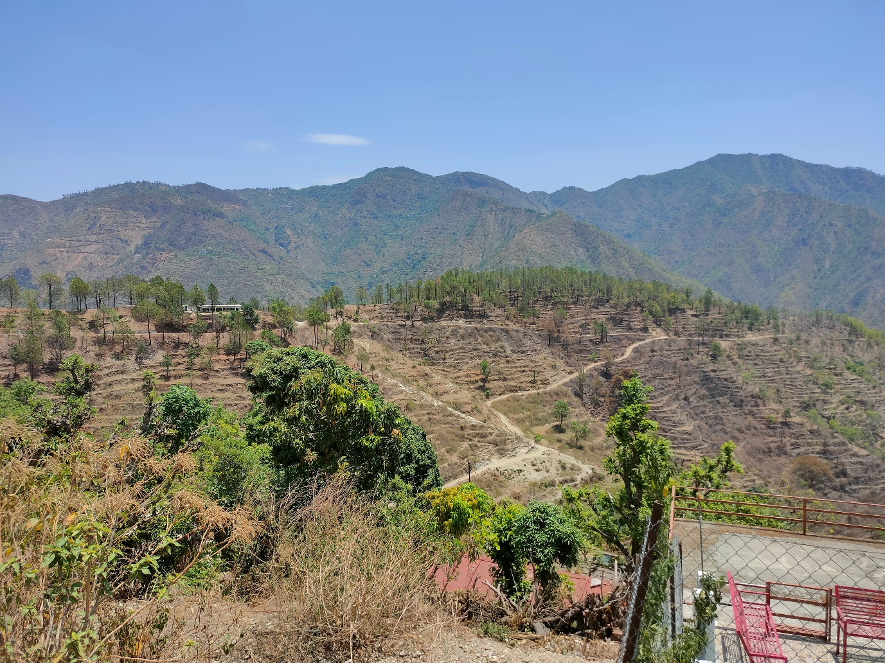

Fig : Unpaved rural roads further down the village with no public transport available

**Challenges Faced:** Despite its positive impact, several challenges persist that hinder the program's effectiveness:

* **Irregular Service**: The lack of proper infrastructure, including roads and delivery systems, has resulted in irregular gas cylinder deliveries. This inconsistency affects the reliability of clean cooking fuel for households.
* **Fuel Stacking**: While LPG is used for cooking, many households still rely on firewood for other tasks like boiling water and bathing. This "fuel stacking" indicates a need for a more holistic approach to address all fuel needs.

**Geographical Challenges:** The hilly terrain of any Himalayan village poses unique challenges, particularly for elderly residents. The difficulty in transporting heavy gas cylinders up narrow and winding paths exacerbates the burden on already vulnerable populations. Addressing these geographical realities is crucial for ensuring equitable access to the benefits of the Ujjwala Yojana.

#### **Recommendations**

Based on my observations and insights, the following recommendations are proposed to enhance the effectiveness of PMUY in [Name of Village]:

1. **Infrastructure Upgrades**:
   * Invest in improving local roads and pathways to facilitate smoother and more reliable gas cylinder deliveries. This will address the current irregularities and ensure consistent access to clean cooking fuel.
2. **Comprehensive Fuel Solutions**:
   * Develop strategies to promote alternative fuel sources or technologies that can complement LPG for tasks beyond cooking. This approach will reduce dependency on firewood and further improve indoor air quality.
3. **Tailored Support for Elderly Residents**:
   * Introduce lighter and more manageable gas cylinder options for elderly residents or establish a dedicated support system to assist them in transporting cylinders. This initiative will alleviate physical burdens and enhance accessibility.
4. **Community Engagement and Awareness**:
   * Conduct regular community workshops and awareness campaigns to educate residents about the benefits of clean cooking fuel and proper usage of LPG. This will foster greater adoption and sustainable use of the provided resources.

#### **Conclusion**

In conclusion, the Pradhan Mantri Ujjwala Yojana has made significant strides in improving the quality of life for residents of [Name of Village] by providing access to clean cooking fuel. However, addressing the identified challenges and implementing the recommended strategies are crucial steps towards maximizing the program's impact and ensuring its sustainability. By adapting to local contexts and needs, PMUY can continue to serve as a transformative initiative in promoting health, gender equality, and environmental sustainability in rural India.

This reflection report aims to provide actionable insights and recommendations for stakeholders involved in the ongoing implementation and future planning of PMUY in [Name of Village].

**Appendices**

• [Press Information Bureau (PIB) - Pradhan Mantri Ujjwala Yojana Achievements](https://pib.gov.in/PressReleseDetailm.aspx?PRID=1947509#:~:text=The%20target%20to%20release%208,was%20achieved%20in%20January%202022.)

• **World Health Organization (WHO)** - [Household air pollution and health](https://www.who.int/news-room/fact-sheets/detail/household-air-pollution-and-health)

• [International Labour Organization (ILO) - Impact of clean cooking fuels on women's empowerment](https://www.sciencedirect.com/science/article/abs/pii/S2214629624000355#:~:text=Households%20where%20women%20are%20empowered,the%20shift%20to%20clean%20fuel.)

• [Indian Council of Medical Research (ICMR) - Study on LPG usage and respiratory health](chrome-extension://efaidnbmnnnibpcajpcglclefindmkaj/https:/main.icmr.nic.in/sites/default/files/icmr_in_news.pdf)

**Note**: The QR code provided below links to the GitHub repository containing all the data presented in the report.

[](https://github.com/aryan-0102/projects/tree/main/Social_Internship)

This repository serves as a comprehensive resource for further exploration and analysis of the findings, recommendations, and additional data collected during the investigation. Feel free to access the repository for detailed information and to engage with the content presented in this report.